Big Data Analytics
1. Introduction to Big Data & Hadoop
1.1 Introduction to Big Data.
1.2 Big Data characteristics, types of Big Data.
1.3 Traditional vs. Big Data business approach.
1.4 Case Study of Big Data Solutions.
1.5 Concept of Hadoop.
1.6 Core Hadoop Components; Hadoop Ecosystem.
PAST QUESTIONS:
- What is Hadoop and Why it Matters. (D23)
- Compare traditional database and big data. (D23, M25)
- Draw Hadoop ecosystem and briefly explain its components. (D23, M25)
- Big data architecture and its characteristics. (D23)
- Big Data and its characteristics. (M24)
- Distance measures for Big Data. (M24, M25)
- Explain 5 V`s of big data. (D24)
- Explain big data enabling technologies. (D24)
- Explain Hadoop architectural model with both components in detail. (D24)

NOTES:

*Big Data :-
Big Data is a term used to describe a collection of large and complex datasets that are difficult to process using traditional data processing techniques and tools.
This data comes in many forms structured (e.g., tables), semi-structured (e.g., JSON, XML), and unstructured (e.g., text, images, video).
It requires advanced technologies and methods for efficient storage, analysis, and visualization.

*Characteristics of Big Data :-
Big Data is defined by a set of characteristics commonly referred to as the 5 V’s — Volume, Velocity, Variety, Veracity, and Value.
5 V`s of Big Data -
- Volume: Refers to the huge amount of data generated every second-ranging from terabytes to petabytes. Example: YouTube uploads 500+ hours of video every minute.
- Velocity: The speed at which data is created, shared, and processed. Data streams in from sensors, social media, and transactions in real-time.
- Variety: Data comes in multiple formats-text, audio, images, videos, logs, sensor data, etc. Handling all these types together is complex
- Veracity: Refers to the trustworthiness and accuracy of the data. Inconsistent, duplicated, or noisy data can lead to wrong insights.
- Value: Not all data is useful. The key is extracting relevant data and turning it into business value through analytics.

*Architecture of Big Data:-
Big Data Architecture is the framework designed to ingest, store, process, and analyze massive volumes of data (structured, semi-structured, and unstructured) efficiently using Big Data technologies.
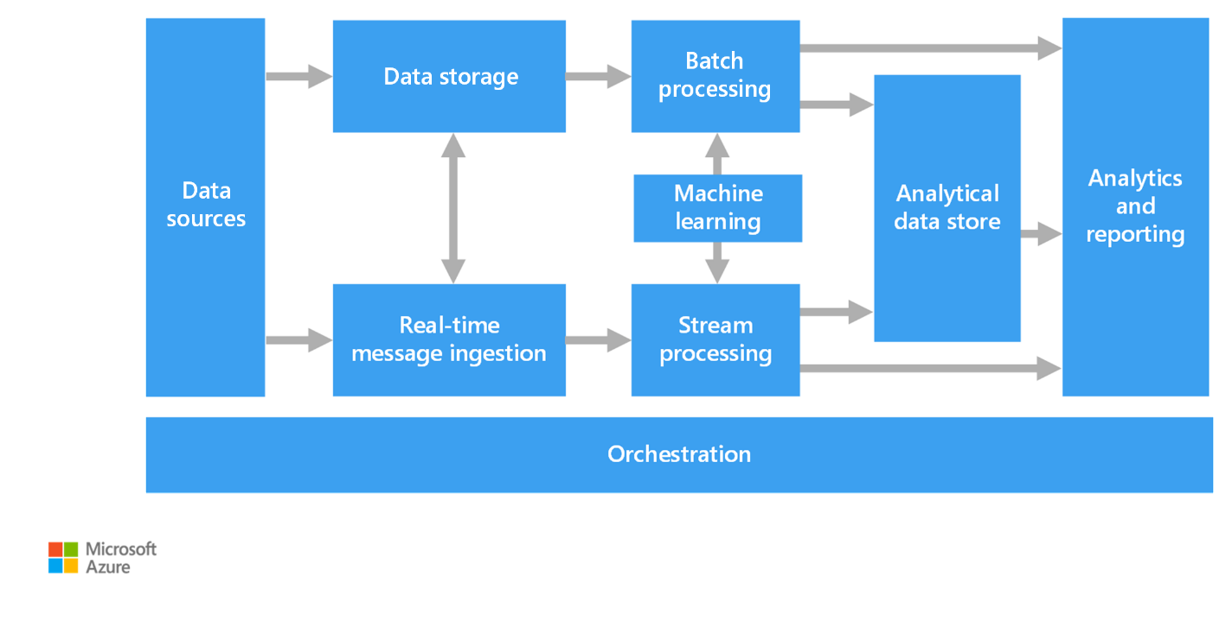
The following are the different components of big data architecture –
1. Data Sources - All big data solutions start with one or more data sources. The Big Data Architecture accommodates various data sources and efficiently manages a wide range of data types. Some common data sources in big data architecture include transactional databases, logs, machine-generated data, social media and web data, streaming data, external data sources, cloud-based data, NOSQL databases, data warehouses, file systems, APIs, and web services.
2. Data Storage - Data storage is the system for storing and managing large amounts of data in big data architecture. Big data includes handling large amounts of structured, semi-structured, and unstructured data.
It does this by using Distributed File Systems, Data lakes, Blob Storage, etc.
3. Batch Processing - Process data with long running batch jobs to filter, aggregate and prepare data for analysis, these jobs often involve reading and processing source files, and then writing the output to new files. Batch processing is an essential component of big data architecture, as it Processes data in large chunks at scheduled intervals.
4. Real-Time Message Ingestion - Big data architecture plays a significant role in real-time message ingestion, as it necessitates the real-time capture and processing of data streams during their generation or reception.
Real-time message ingestion systems are critical for extracting important insights, identifying anomalies, and responding immediately to occurrences.
5. Stream Processing - Stream processing is a type of data processing that continuously processes data records as they generate or receive in real time. It enables enterprises to quickly analyze, transform, and respond to data streams.
6. Analytical Data Store - In big data analytics, an Analytical Data Store (ADS) is a customized database or data storage system designed to deal with complicated analytical queries and massive amounts of data. An ADS is intended to facilitate querying, data exploration, reporting, and advanced analytics tasks, making it an essential component of big data systems for business intelligence and analytics.
Special databases like HBase, Hive, Azure Synapse.
7. Analysis and Reporting - Big data analysis and reporting are the processes of extracting insights, patterns, and trends from huge and complex information to aid in decision-making, strategic planning, and operational improvements.
Tools: Power BI, Excel, Azure Analysis Services.
8. Orchestration - Most big data solutions consist of repeated data processing operations that are executed in a specific order such as Data ingestion, transformation, loading, etc.
Orchestration is the process of automating, scheduling, and managing these workflows efficiently, ensuring that all tasks run in the correct sequence, handle failures gracefully, and scale as needed.

*Types of Big Data :-
Big Data can be classified based on structure into the following types:
1. Structured Data –
Structured data is one of types of big data, characterized by its organized and systematic format.
Structured data is defined as a clear framework, typically represented in tables, rows, and columns.
This type of data is Easy to search, manage, and analyze.
Examples: Tables in relational databases, Spreadsheets.

2. Semi-Structured Data –
Semi-structured data is one of the types of big data that represents a middle ground between the structured and unstructured data categories.
It Doesn’t follow the strict tabular format but still contains tags or markers to separate elements.
It is Partially organized but not as rigid as structured data.
Examples: XML, JSON, CSV files, email headers.

3. Unstructured Data –
Unstructured data is one of the types of big data that represents an unorganized collection of information.
It lacks a consistent structure, making it more challenging to organize and analyze.
Examples: Images, videos, audios, web pages, social media data.
4. Quasi-Structured Data –
Data that is irregular or inconsistent, difficult to organize into fixed structures.
Examples: Web clickstreams, server logs.

**Traditional vs Big Data :-
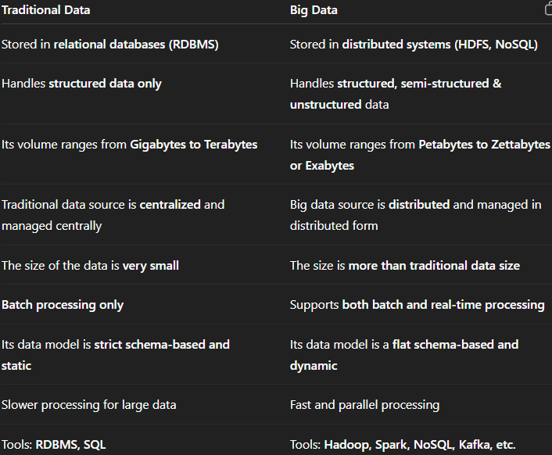

*Concept of Hadoop :-
Hadoop is an open-source framework used to store and process large volumes of data in a distributed computing environment. It allows data to be split across multiple machines (nodes) and processed in parallel, making it ideal for Big Data processing.
Key concept:
1. Distributed Storage - Hadoop uses HDFS (Hadoop Distributed File System) to store large data sets across many computers.
2. Parallel processing – Uses MapReduce programming model to process data in parallel across nodes.
3. Scalability – Easily scales by adding more machines to the cluster.
4. Fault Tolerance – If one node fails, Hadoop replicates data to ensure no data loss.
5. Open-source & Cost-effective – It runs on commodity hardware, reducing infrastructure cost.

**Hadoop Ecosystem & its components :-
Hadoop Ecosystem is a platform or a suite which provides various services to solve the big data problems. It includes Apache projects and various commercial tools and solutions. There are three major elements of Hadoop i.e. HDFS, MapReduce, YARN.
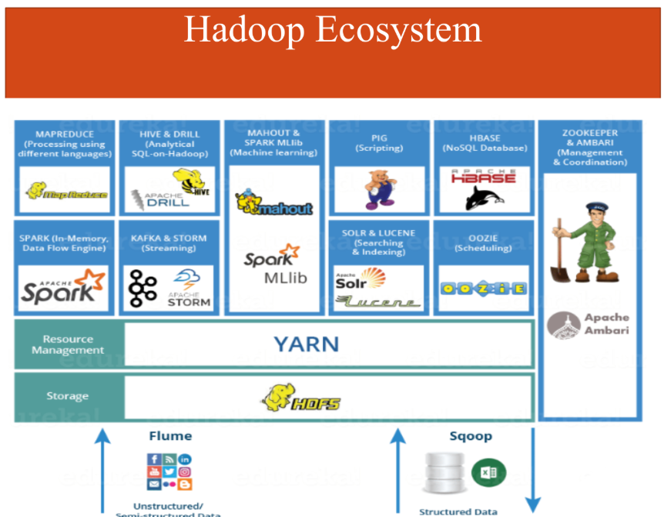
1. HDFS - Hadoop Distributed File System is the primary or major component of Hadoop ecosystem and is responsible for storing large data sets of structured or unstructured data across various nodes and thereby maintaining the metadata in the form of log files.
HDFS consists of two core components i.e.
Name node – Name node is the prime node which contains metadata.
Data Node – Data node stores the actual data.
HDFS maintains all the coordination between the clusters and hardware, thus working at the heart of the system.
2. YARN - Yet Another Resource Negotiator, as the name implies, YARN is the one who helps to manage the resources across the clusters. In short, it performs scheduling and resource allocation for the Hadoop System.
It consists of three major components:
- Resource Manager – It has the privilege of allocating resources for the applications in a system.
- Node Manager – It monitors the resources on each node.
- Application Manager - Application manager works as an interface between the resource manager and node manager and performs negotiations as per the requirement of the two.
3. MapReduce - MapReduce is a distributed data processing framework in the Hadoop ecosystem that allows the processing of large datasets in a parallel and fault-tolerant manner across multiple machines.
MapReduce makes the use of two functions i.e. Map() and Reduce() whose task is:
- Map() performs sorting and filtering of data and thereby organizing them in the form of group.
- Reduce(), as the name suggests does the summarization by aggregating the mapped data.
4. Pig – Pig is a Query based language similar to SQL. It is a platform for structuring the data flow, processing and analyzing huge data sets.
5. Hive - With the help of SQL methodology and interface, HIVE performs reading and writing of large data sets. However, its query language is called as HQL (Hive Query Language).
It is highly scalable as it allows real-time processing and batch processing both.
6. Spark- It contains a Machine Learning Library (MLlib) for providing enhanced machine learning and is widely used for data processing. It also supports Java, Python, and Scala.

**Hadoop Architecture & its components :-
The Hadoop Architecture Mainly consists of 4 components.
  - MapReduce
  - HDFS (Hadoop Distributed File System)
  - YARN (Yet Another Resource Negotiator)
  - Common Utilities or Hadoop Common

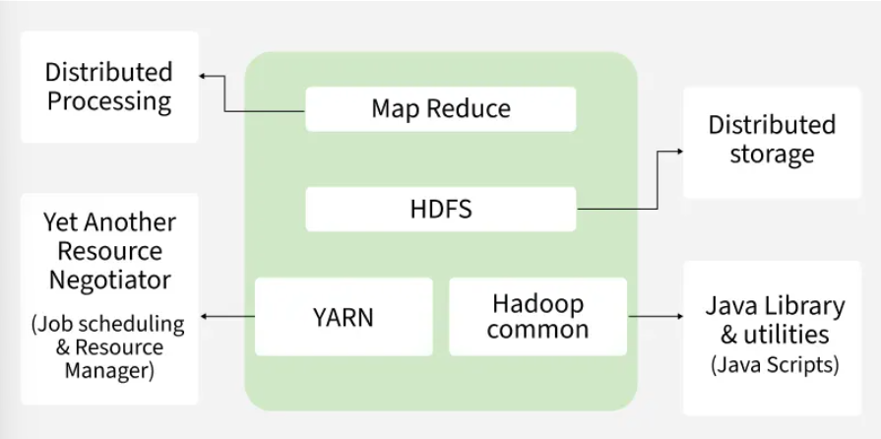

1. MapReduce -
MapReduce is a data processing model in Hadoop built on top of the YARN framework. Its main feature is distributed and parallel processing across a Hadoop cluster, which significantly boosts performance when handling Big Data. Since serial processing is inefficient at large scale, MapReduce enables fast and efficient data processing by splitting the workload into two phases: Map and Reduce.

2. HDFS -
HDFS (Hadoop Distributed File System) is utilized for storage permission. It is mainly designed for working on commodity Hardware devices (inexpensive devices), working on a distributed file system design. HDFS is designed in such a way that it believes more in storing the data in a large chunk of blocks rather than storing small data blocks.
HDFS in Hadoop provides Fault-tolerance and High availability to the storage layer and the other devices present in that Hadoop cluster.

3. YARN (Yet Another Resource Negotiator) -
YARN is the resource management layer in the Hadoop ecosystem. It allows multiple data processing engines like MapReduce, Spark, and others to run and share cluster resources efficiently. It handles two core responsibilities:
- Job Scheduling: Breaks a large task into smaller jobs and assigns them to various nodes in the Hadoop cluster. It also tracks job priority, dependencies, and execution time.
- Resource Management: Allocates and manages the cluster resources (CPU, memory, etc.) required for running these jobs.

4. Hadoop Common (Common Utilities) –
Hadoop Common, also known as Common Utilities, includes the core Java libraries and scripts required by all the components in a Hadoop ecosystem such as HDFS, YARN and MapReduce. These libraries provide essential functionalities like:
- File system and I/O operations
- Configuration and logging
- Security and authentication
- Network communication

